**LAB NO:05**

**OBJECTIVE:** TO BECOME FAMILIAR WITH RMI OBJECT SERIALIZATION

**TASK:** Develop any simple application to demonstrate object passing in RMI. (Expl: Make a class of your own and use its objects as arguments and return types for RMI)

REMOTE INTERFACE:

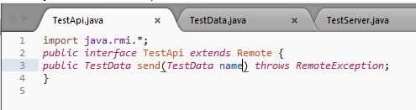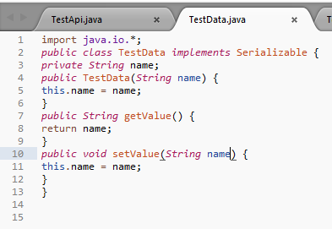

SERVER MAIN CLASS:

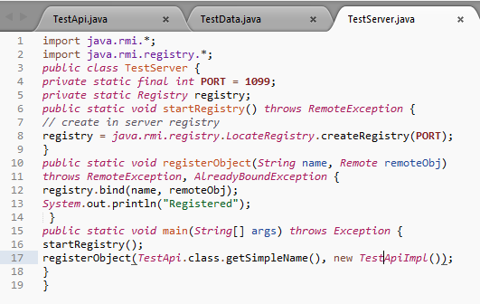

CLIENT MAIN CLASS:

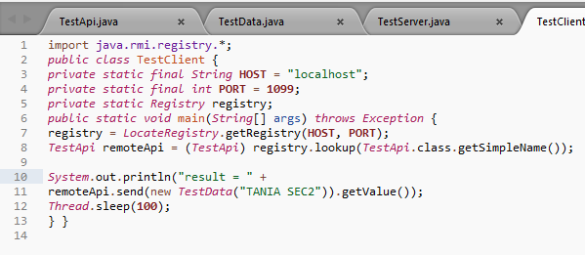

REMOTE OBJECT CLASS:

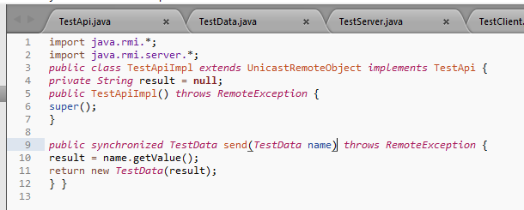

OUTPUT:

